
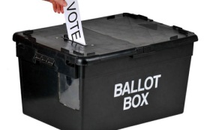
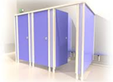
SCHEMATIC II (b): SET-UP FOR VOTING IN A VOTING POINT

Queue
Security Personnel
APO II Ballot Paper Issuance & Inking
Security Personnel

APO III Queuing
APO I (Overseer)
APO (VP)
Voting Cubicles
Observers
Party Agents
Entry/Exit

