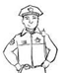
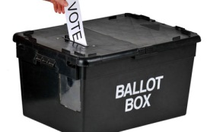
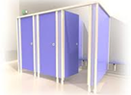
SCEMATIC I (b): SET-UP FOR VOTING IN STAND-ALONE POLIING UNIT

APO III Queuing
Queue
Security Personnel
APO II Ballot Paper Issuance & Inking
Security Personnel

APO I (Overseer)
PRESIDING OFFICER
Voting Cubicles
Observers
Party Agents
Entry/Exit

